Wind Energy HW: Matlab Portion

%%

% Problem 1

U = 1:0.1:30; % m/s

rho = 1.225; % kg/m^3

PD = 0.5.\*rho.\*U.^3; % W/M^2

plot(U,PD)

xlabel("Wind Veloctiy (m/s)");

ylabel("Power Density (W/m^2)");

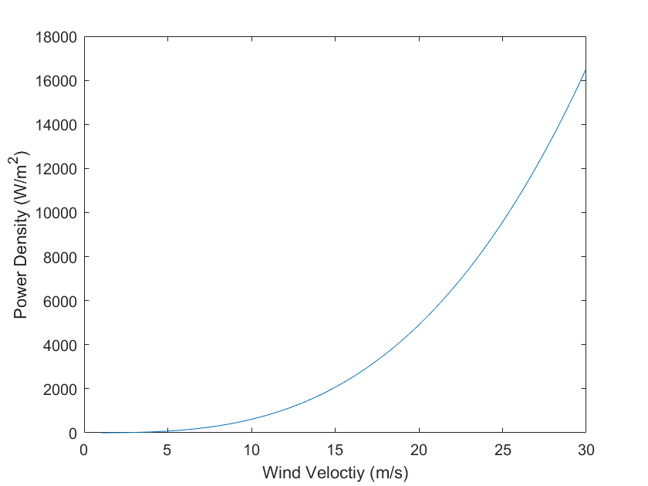

%%

% Problem 2

rho = 1.225;

U = [10, 20, 30];

D = 10:50;

P1 = (rho.\*pi.\*D.^2/8).\*U(1)^3;

P2 = (rho.\*pi.\*D.^2/8).\*U(2)^3;

P3 = (rho.\*pi.\*D.^2/8).\*U(3)^3;

plot(D,P1,D,P2,D,P3)

